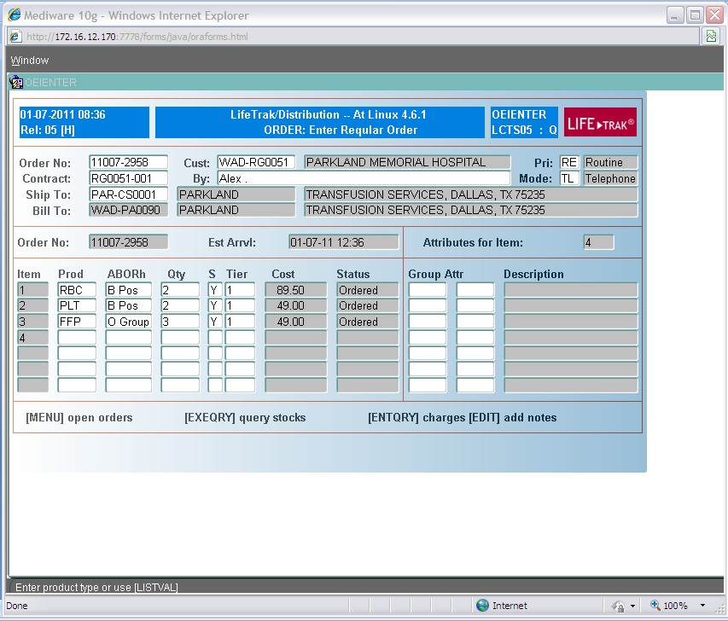
AFTER ORDER IS ENTERED – ORDER SLIP GENERATES
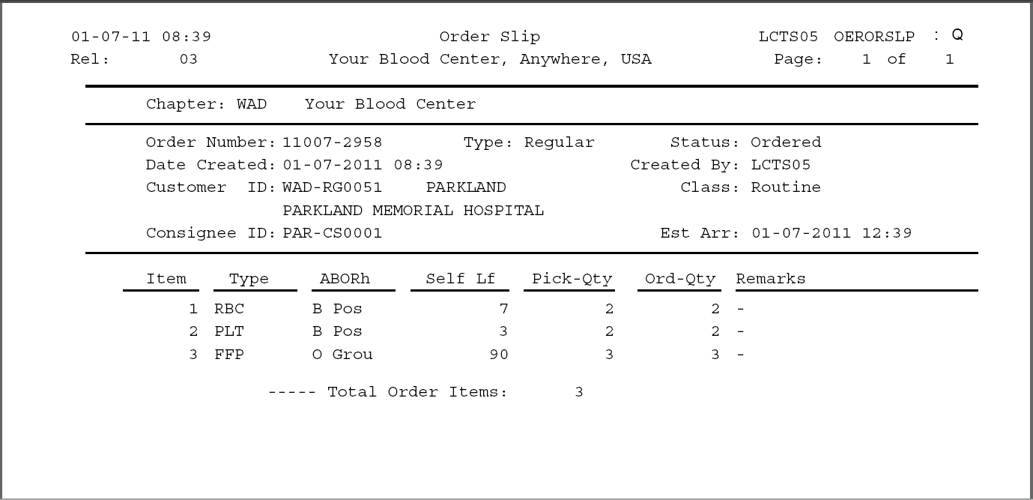
PROCEED TO PACKING

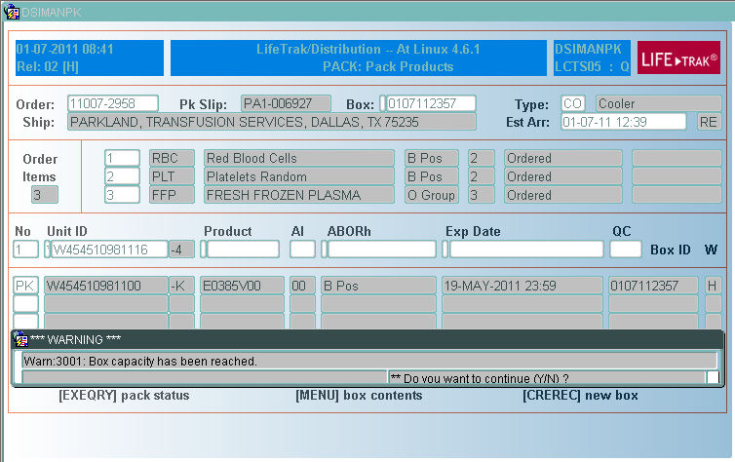
IF BOX CAPACITY IS REACHED YOUWILL RECEIVE A WARNING - YOU ARE ABLE TO PROCEED
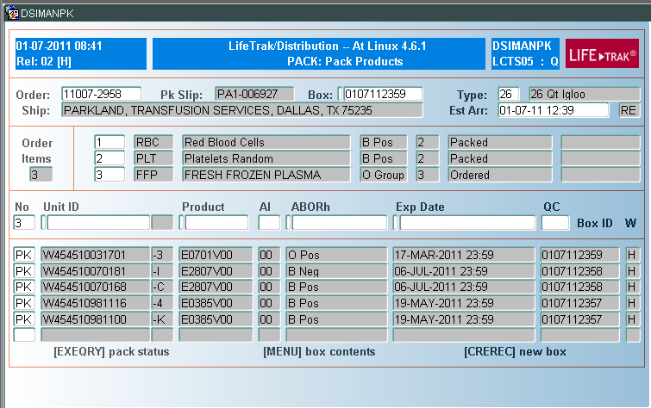
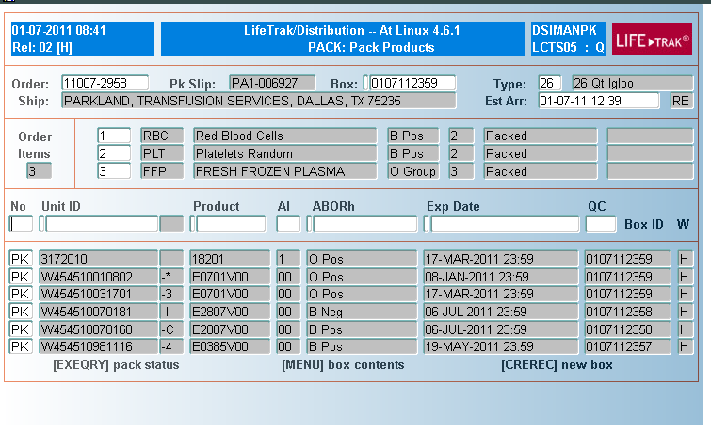

PROCEED TO SHIPPING THE PRODUCT

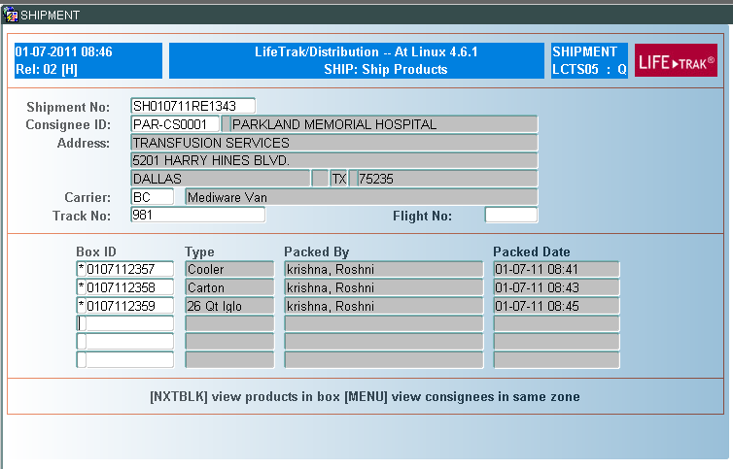
AFTER SHIPMENT A PACKING LIST WILL BE GENERATED
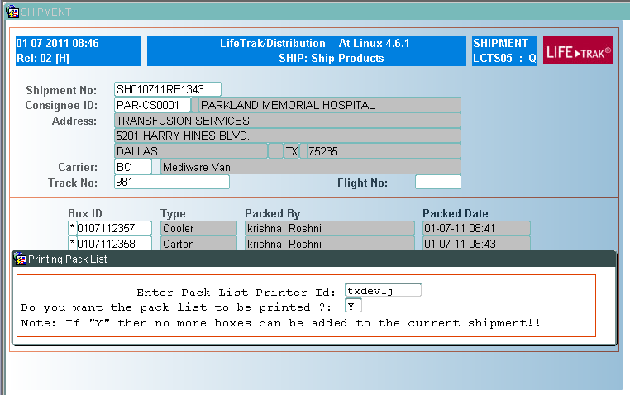
ALWAYS ENTER “y” TO PRINT THE PACKLIST, OTHERWISE UNABLE TO CONFIRM THE SHIPMENT
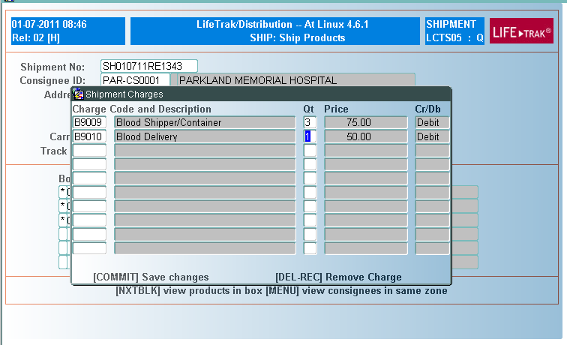
ABLE TO ADD ADDITIONAL CHARGES TO THE SHIPMENT PRIOR TO CLOSING.
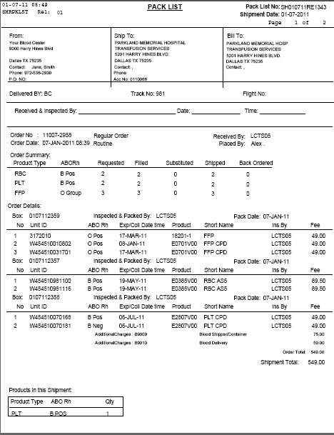
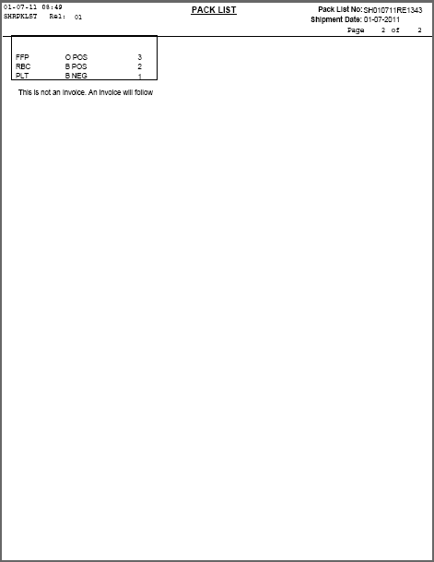
AFTER SHIPMENT PRODUCTS MUST BE CONFIRMED THE CUSTOMER RECEIVED TO ALLOW THEM TO BE RETURNED TO BLOOD CENTER

